Enterprise Sales Analytics
Dataset: Link
Tools Used: MySQL , SQL (Structured Query Language), MS Excel, PowerBi Github repo-link: Enterprise Sales Analytics
Objective: Analyze sales performance, revenue trends, and business insights.

Sales Contribution by Product
Objective:
Calculate total revenue and percentage contribution of each product.
Result:
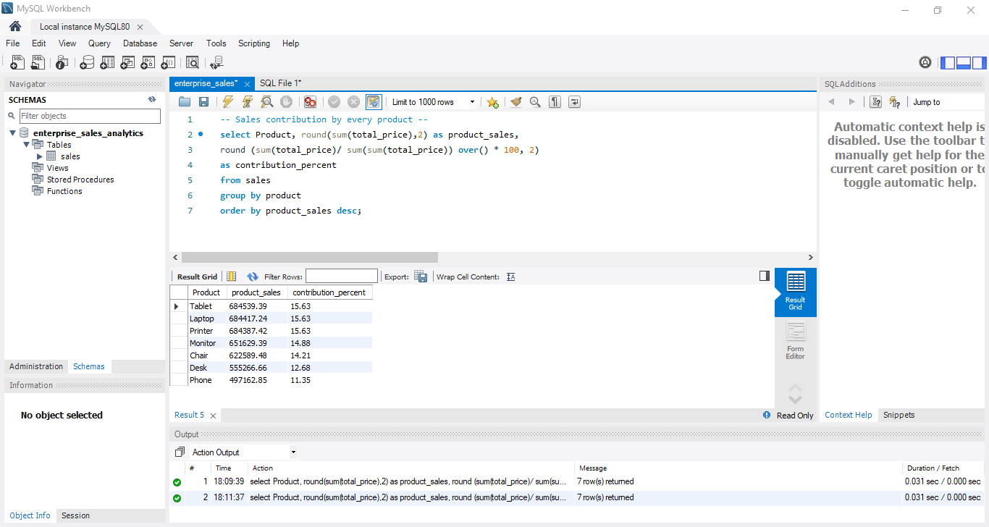
Output:
- product_sales → Total revenue per product
- contribution_percent → Share of total revenue
Insight:
Identifies top revenue-generating products for business prioritization.

Monthly Best Salesperson
Objective: Identify the top-performing salesperson for each month based on total revenue.
Result:
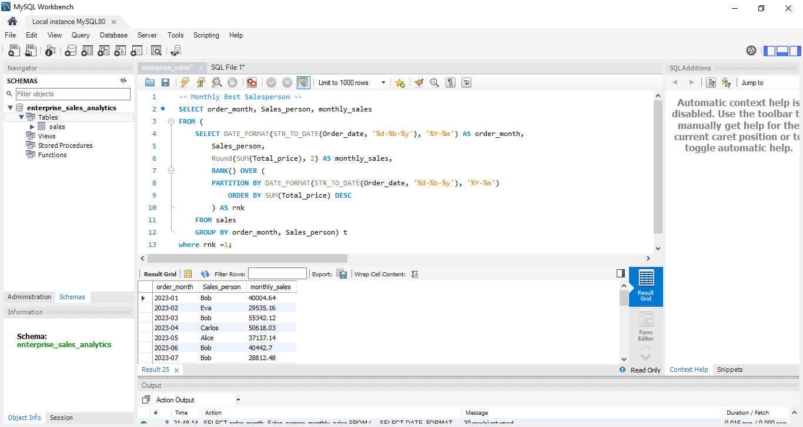
Output:
- order_month → Month
- Sales_person → Top performer
- monthly_sales → Total sales for the month
Insight:
Highlights the best-performing salesperson each month.

Month-Over-Month (MoM) Growth
Objective: Measure monthly revenue growth trend.
Result:
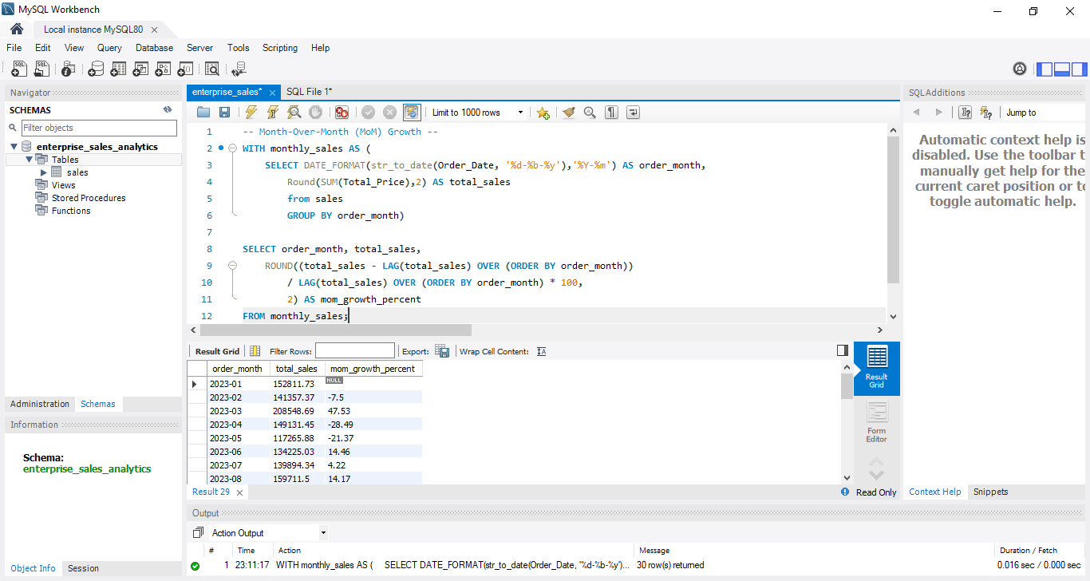
Output:
- order_month → Month
- total_sales → Monthly revenue
- MoM_growth_percent → Growth rate vs previous month
Insight:
Tracks revenue growth and identifies business trends.

Customer Lifetime Value (CLV)
Objective: Calculate total revenue generated by each customer.
Result:
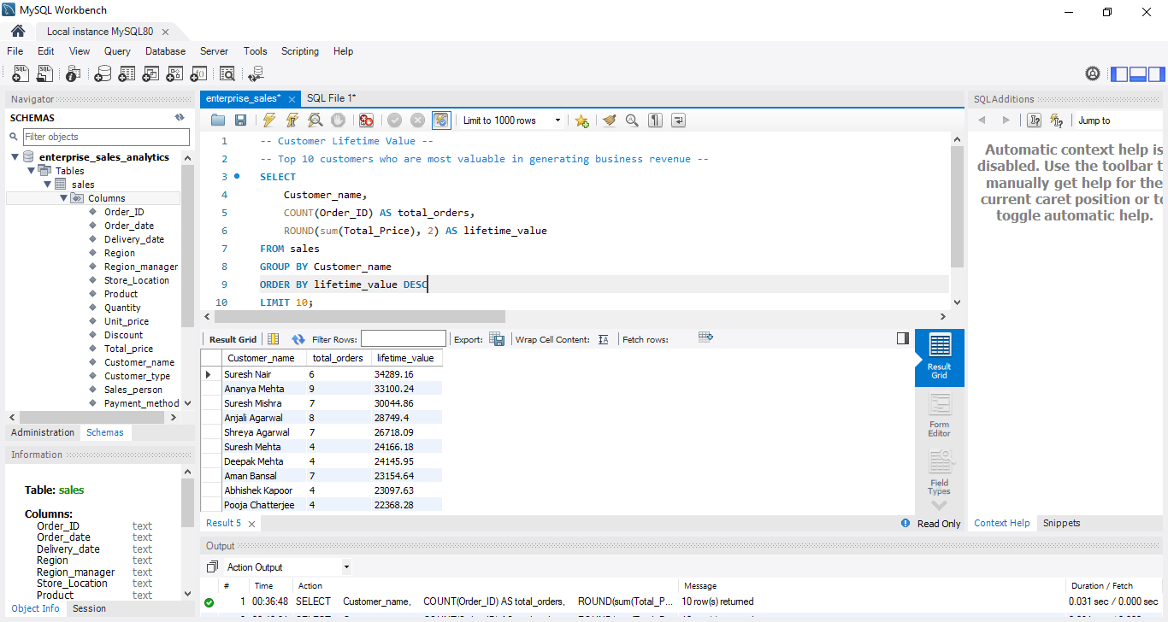
Output:
- Customer_name → Customer
- total_orders → Number of orders
- lifetime_value → Total revenue generated
Insight:
Identifies high-value customers for retention and targeting.

Best Selling Product in Each Region
Objective: Identify the highest-revenue product in each region.
Result:
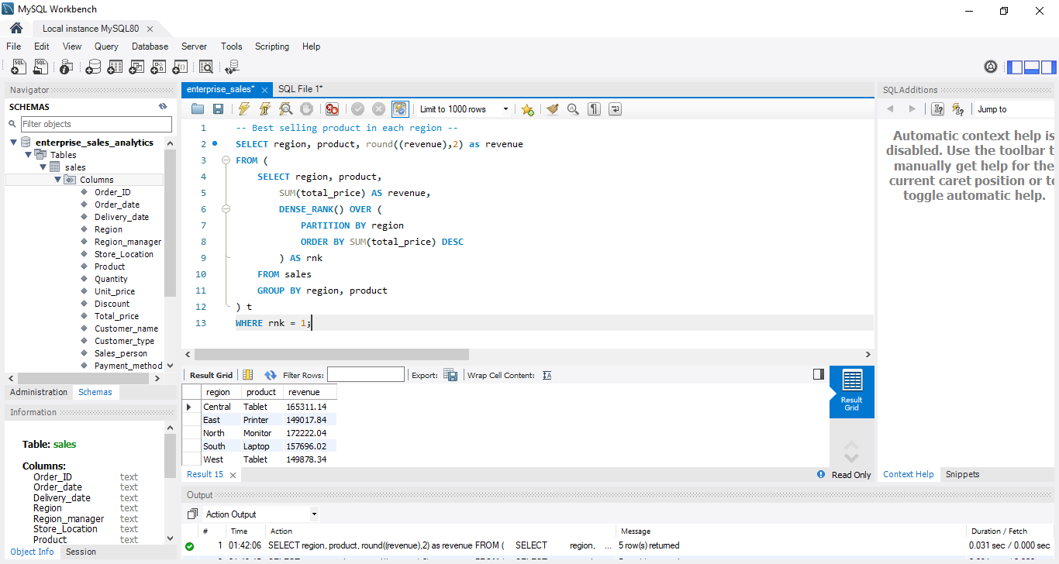
Output:
- region → Region
- product → Best-selling product
- revenue → Total revenue
Insight:
Identifies top product in each region for regional optimization.

Sales by Region Analysis
Objective: Compare total sales across regions.
Method: Aggregated regional sales and visualized using Excel chart.
Result:
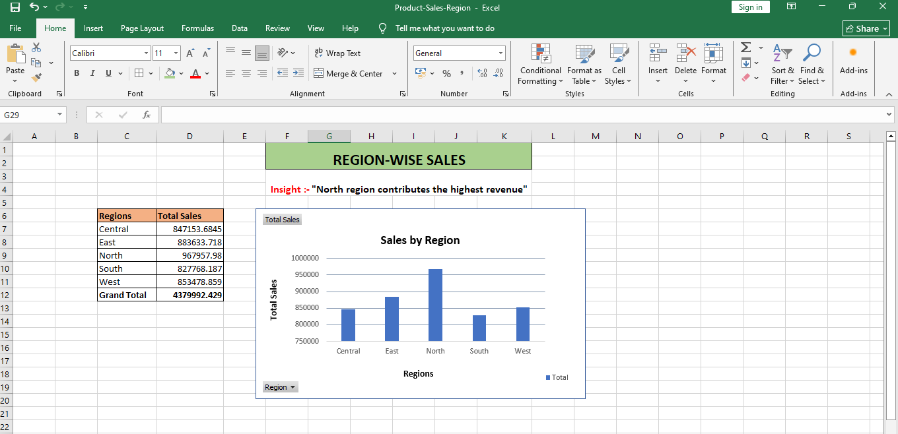
Insight:
North region is the top revenue contributor, indicating strongest market performance.

Monthly Sales Trend Analysis
Objective: Analyze monthly sales trend and seasonality.
Method: Aggregated monthly sales and visualized trend using Excel.
Result:
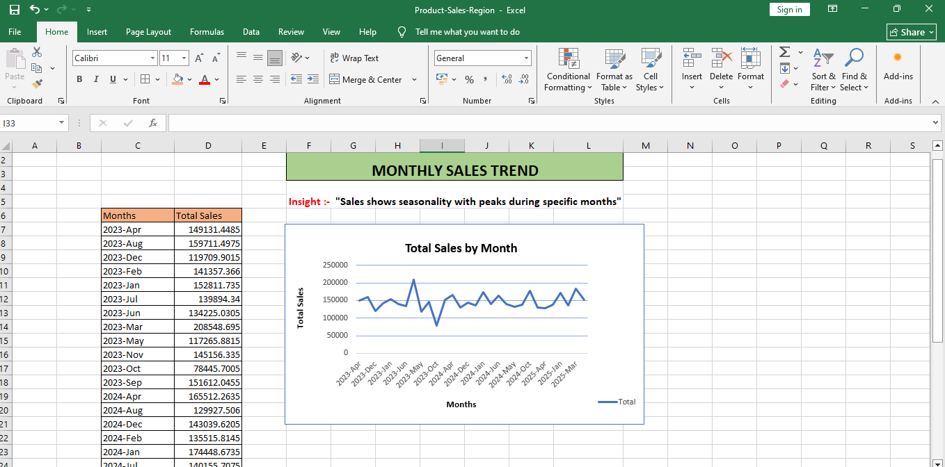
Insight:
Sales show seasonal fluctuations with peak months indicating higher demand.

